Progress report 2023-07-28

RG Wells – 22961305

**Restatement of Goals:**

The major goals and milestones of this project are as follows:

1. Project Proposal **✓**
2. Literature Review **✓**
3. 2D Simulation **✓**
4. Create Model **✓**
5. Compile design requirements **✓**
6. Design Platform **(in progress)**
7. Simulate Platform **(in progress)**
8. Produce Prototype **(in progress)**
9. Validate Model
10. Finalise Report

**Project Proposal: Completed 2023-03-17**

Defined the background, objectives, motivation. Put forth an initial plan, risk assessment, and end of life strategy.

**Literature Review: Completed 2023-04-08**

Reviewed the literature of general USAR robots, as well as the previous reports relating to this project.

**2D simulation: Completed 2023-04-08**

Algodoo software was used to get a feel for how the motion of LIMs work, which would later inform the model. The simulation had several limitations which prevent it from accurately describing the forces involved, but nevertheless provided great insight into the motion of LIM systems.

**Create model: Completed 2023-05-24**

Created a mathematical model to describe the motion of a LIMed system by combining inertial and kinematic equations in MATLAB. The model describes the motion of four states, rolling without flipping, rolling with flipping, flipping without rolling, and climbing. These equations were then combined to create an animation of the stair climbing process.

**Compile design requirements: Completed 2023-05-06**

Documented the stakeholder and engineering requirements for the design phase.

**Design Platform: In progress**

The USAR platform has been designed in CAD, largely based on Powrie’s design. There are a few adjustments, mostly relating to tolerances, that need to be made on the CAD design before drawing files will be produced and sent for machining and laser cutting at the university.

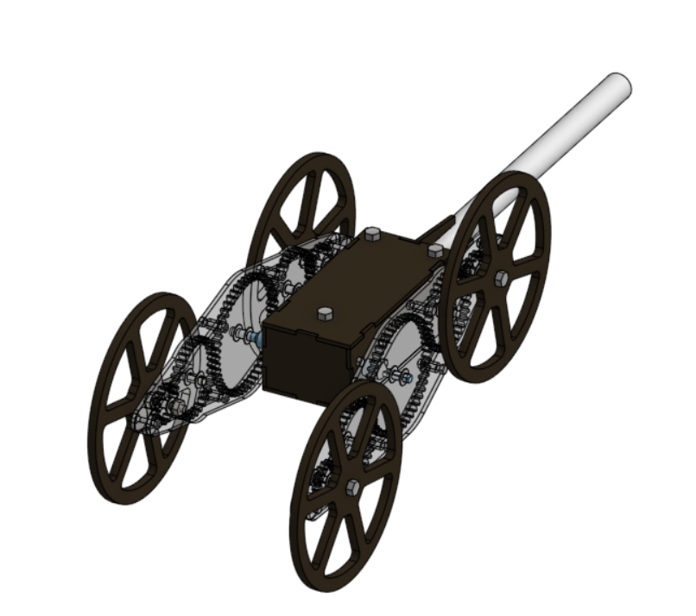

Figure 1 Initial CAD design

**Simulate Platform: In progress**

The CAD model has been imported into the simulation software, Drake. Initial tests indicate that the gearing and inertia are reflected accurately in the simulation. The current focus is on implementing accurate friction for the wheels and realistic torque profiles for the motors.

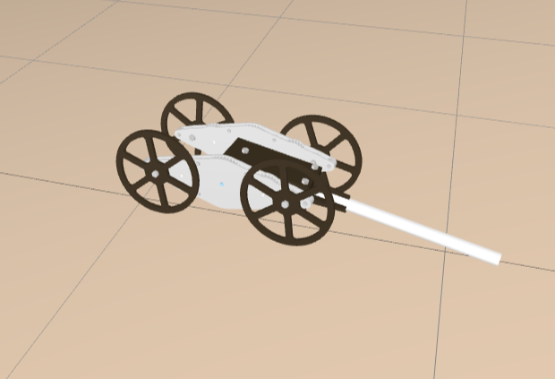

Figure 2 Simulation of CAD model

**Produce Prototype: In progress**

A preliminary build was completed, however without the appropriate shafts as they would take additional time to manufacture. Because of this, the gears weren’t aligned properly and the device would not roll properly. Additionally, the plastic shafts used were too weak and broke during the device’s operation. These issues, along with some hole tolerance issues, will be addressed in the next iteration of the design.

**Previous and future plans:**

The initial Gantt. Chart presented did not take into account the iterative design and modelling process, it has been remade into a more accurate plan. The only potential bottleneck would be waiting for the MMW to produce parts, so it is a priority to update the design and send the work request ASAP.

Figure 3 Initial Gantt. Chart

Figure 4 Updated Gantt. Chart